# Name: Tijesu Olalekan (x17347773)

# Use case

Find customer

# Scope

The scope of this use case is for a system administrator to serach the database for a customer.

# Description

This use case describes the entering of the specifics of a customer by the system administrator to find a particular customers details.

# Flow Description

## Precondition

Customer must exist in database and details must be entered accurately.

## Activation

This use case starts when information about a customer in required or when button is pressed.

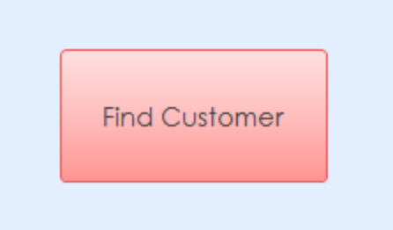

## Main flow

1. System administrator goes to the “customer_input” form.
2. Clicks on the area that the have information on e.g Customer Code
3. Clicks on the “find customer” button.
4. Enters the information the is known
5. The system presents the complete details of the customer with the matching detail.

## Alternate flow

(A1 Enetering wrong information)

1. Continue in main flow till step 3 .
2. Enter incorrect information.
3. The system will not give any customer.

## Termination

After system administer searches the details entered into form.

## Post condition

The system displays information of searched customer.